EXPERIMENT- 08
Convert an Image to Show Outline using Canny Function
Aim
To write a Python code to detect edges and display the outline of objects in an image using the Canny edge detection method in OpenCV.
Input Image
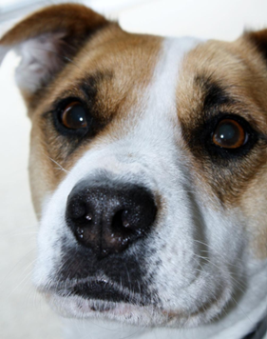
Code
import cv2
from google.colab.patches import cv2_imshow
from google.colab import files
uploaded=files.upload()
image_path=list(uploaded.keys())[0]
image=cv2.imread(image_path,cv2.IMREAD_GRAYSCALE)
if image is None:
print("Error: Image not found")
else:
edges=cv2.Canny(image,30,100)
print("Original Image")
cv2_imshow(image)
print("Canny Edge Image")
cv2_imshow(edges)
Output Image
Canny Edge Image
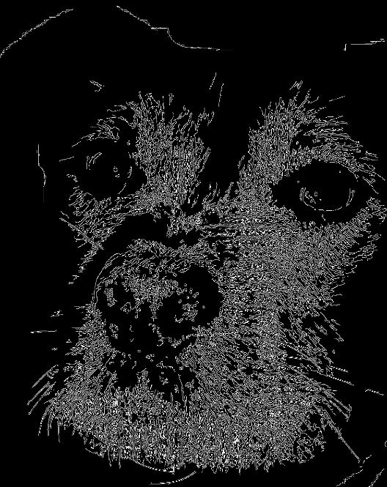
Result
Thus, the outline of the image was successfully detected using the Canny edge detection method.

